From Prof. Kim Oanh
I donot find the public seminar organized by the Center.
Please use AirQC consistently (no need to spell) and the AirQC team.
For the Heal-haze and Canbreathe, please spell only one time and provide the links to the project websites at Canberra.
Ktoo can contact me to get some photos where relevant.

Events

Date | 25 July 2025
Title | Roundtable Discussion on Sustainable Last Mile Delivery, Manila, Philippines
paragraph | On 25th July 2025, Dr. Lai Nguyen Huy, the Deputy Director, attended the Roundtable Discussion on Sustainable Last Mile Delivery organized by the Institute for Climate and Sustainable Cities (ICSC) in Manila, the Philippines.  Dr. Huy presented the key findings of the background study of last-mile delivery for Thailand’s case study. AirQC actively contributed to the regional report which includes four case studies in Southeast Asia, i.e., Indonesia, the Philippines, Thailand, and Vietnam
Photo | 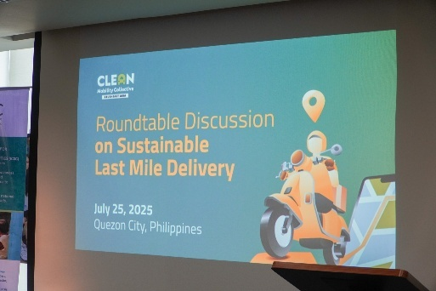  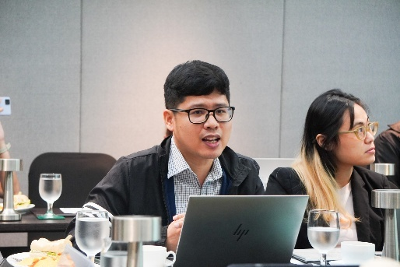

Date | 26 June 2025
Title | Regional Policy Dialogue Workshop in Vientiane, Lao PDR
paragraph | On 26th June 2025, Prof. Kim Oanh and Dr. Lai Nguyen Huy, representatives of AirQC participated in the high-level regional policy dialogue in Vientiane, Lao PDR, which was co-hosted by the University of Canberra (Australia), National University of Laos, and the University of Health Sciences Laos.  The workshop brought together over 40 delegates to introduce two projects for which the AirQC is the key partner: Climate change adaptation to smoke haze for improved child health in Southeast Asia (HEAL-HAZE) and Climate Attribution of Wildfire Smoke Impacts on Priority Population Health in Southeast Asia and Australia (CANBREATHE).  The workshop provided key opportunities to understand the social, political and economic barriers to mitigation which empowered the health sector to deal with smoke-haze from biomass open burning.
Photo | 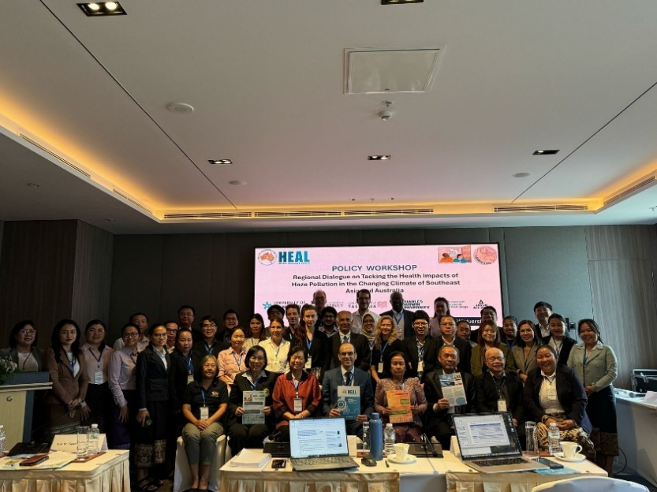  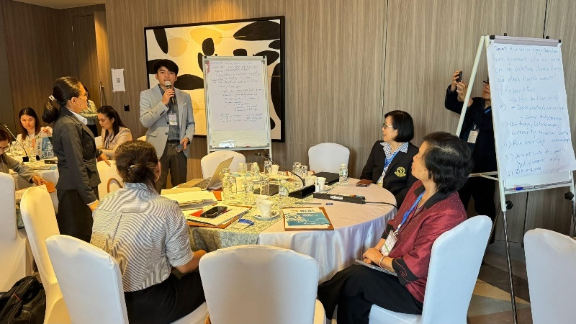

Date | 17 June 2025
Title | Policy Dialogue Workshop on Tackling the Health Impacts of Haze Pollution in Southeast Asia and Australia in Bangkok, Thailand
paragraph | On 17th June 2025, Prof. Kim Oanh and Dr. Lai Nguyen Huy, representatives of AirQC participated in the policy dialogue workshop on “Tackling the Health Impacts of Haze Pollution in Southeast Asia and Australia” held in Bangkok, Thailand. Policy dialogue is an important work package of HEAL-HAZE and CANBREATHE.  This joint workshop aimed to engage policymakers and other stakeholders to prioritize solutions against haze pollution for affected communities and schools, co-create a platform for policy dialogue and knowledge exchange, and identify opportunities for regional cooperation on tackling the health impacts of air pollution and climate change.  Prof. Kim Oanh, Director of AirQC, delivered a keynote presentation on “Overview of Smoke Haze Pollution from Wildfires and Agricultural Burning in Southeast Asia”. The AirQC team actively participated in the discussion groups which aimed systematically map existing interventions and policies; engage multi-sectoral stakeholders to prioritize adaptation solutions; Identify implementation challenges, barriers, and enablers; co-design adaptation interventions tailored to regional needs; Empower health sector to deal with smoke haze; and understand the social, political and economic barriers to mitigation.
Photo | 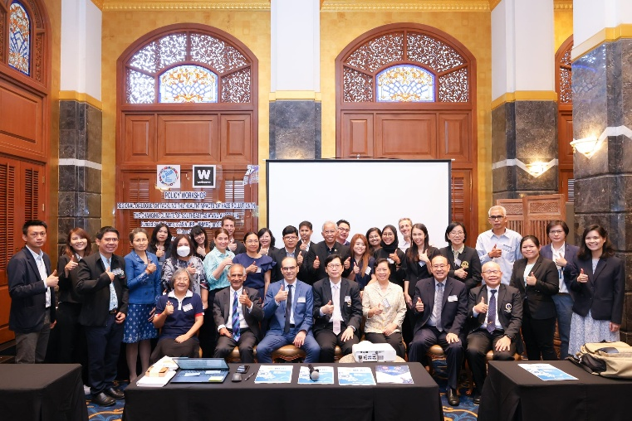

Date | 23 April, 2025
Title | Training Workshop on “Science-Based Tools for Air Quality Management”, Hanoi, Vietnam, 23rd April 2025
paragraph | On 23 April 2025, a Training Workshop on “Science-Based Tools for Air Quality Management” was held at the Green One UN House in Hanoi, Viet Nam. The event was co-organized by Clean Air Asia, the World Health Organization (WHO) Viet Nam, and the United Nations Development Programme (UNDP). The workshop gathered policymakers, researchers, and civil society representatives from across the region to strengthen partnerships and enhance understanding of air pollution challenges and their impacts.  The workshop aimed to promote regional exchange and support integrated approaches that deliver co-benefits for clean air and decarbonization. Participants explored science-based policymaking through the sharing of best practices, analytical tools, and case studies from Viet Nam, China, and Thailand.  Prof. Nguyen Thi Kim Oanh, Director of AirQC, delivered a lecture on “Air Quality Data for Effective Air Quality Management – Best Practice in Asia and Lessons for Vietnam” during the pre-event training session “Opportunities to Strengthen Air Quality and Its Management in Vietnam.” She shared insights on improving air quality management systems, advancing data-driven policy, and fostering regional cooperation and knowledge exchange.
Photo | 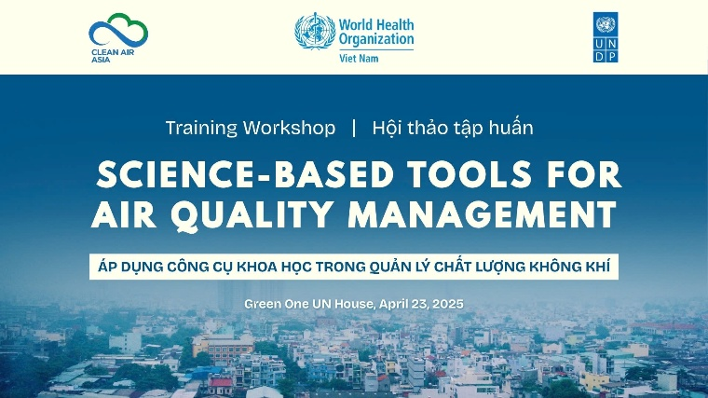  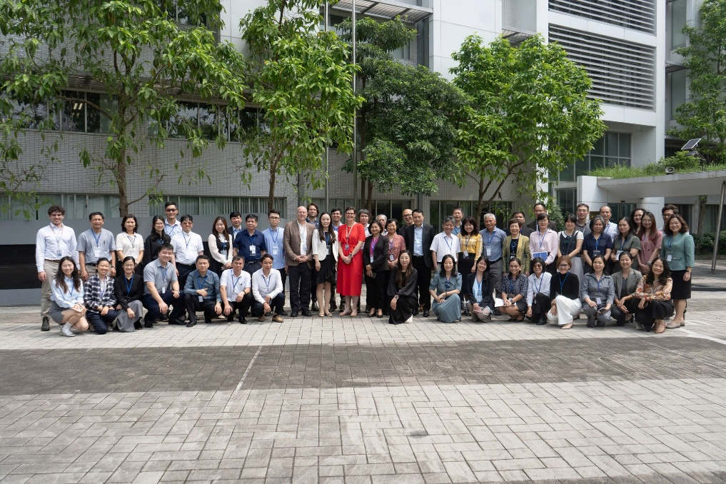

Date | 2-3 October 2024
Title | “Regional Dialogue on Climate and Health”, 2nd – 3rd October 2024
paragraph | On 2–3 October 2024, Prof. Nguyen Thi Kim Oanh, Director of AirQC participated as a speaker and panelist at the “Regional Dialogue on Climate and Health” organized by the Embassy of France to Thailand at Mahidol University.  Prof. Kim Oanh delivered the presentation titled “Co-control of Emission Sources for Multiple Benefits,” She highlighted the importance of integrated strategies to simultaneously improve air quality, protect public health, and mitigate climate change. During the panel discussion, she emphasized the need for collaborative research and cross-sectoral policy approaches to enhance co-benefits across the environment, health, and climate domains.  The dialogue brought together experts, researchers, and policymakers to discuss the critical intersection of climate change and public health. The event aimed to strengthen regional partnerships and enhance collective capacity to address health impacts associated with climate change, fostering more resilient and adaptive health systems in the Asia-Pacific region.  Details of the event can be found at Climate and Health Regional Dialogue – IRASEC.
Photo | 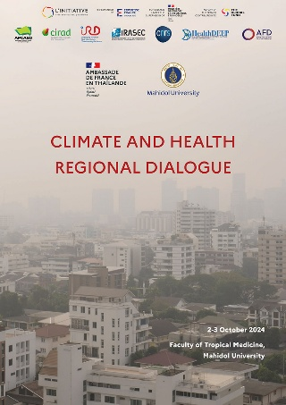

Date | 23 September 2024
Title | Regional Workshop on “National Air Pollutant Emissions Inventory” 23rd September 2024
paragraph | On 23 September 2024, Prof. Nguyen Thi Kim Oanh, Dr. Lai Nguyen Huy, and Dr. Truong Thi Huyen from the AirQC participated online in the Regional Workshop on Developing National Air Pollutant Emissions Inventory, a pre-event to the Fifth Ministerial Meeting of the Regional Forum on Health and Environment of Asia Pacific, held in Jakarta, Indonesia. The workshop was organized by the United Nations Environment Programme (UNEP) to enhance regional capacity and knowledge exchange on emissions inventory development.  The workshop aimed to support countries in the Asia-Pacific region by strengthening their technical capacity and facilitating the sharing of best practices for developing comprehensive air pollutant emissions inventories. It focused on fostering evidence-based air quality policies and assessing the associated health impacts of air pollution.  As an invited speaker, Prof. Kim Oanh presented the initial findings of the AIT–EANET project on “Emissions Inventory and Source Apportionment Stocktaking.” Her presentation highlighted key methodologies and frameworks to support countries in developing robust emissions inventories, emphasizing the role of these inventories in informing effective policymaking and advancing public health protection across the region.  Details of the event can be found at UNEP – Regional Workshop on Developing National Air Pollutant Emissions Inventory.
Photo | 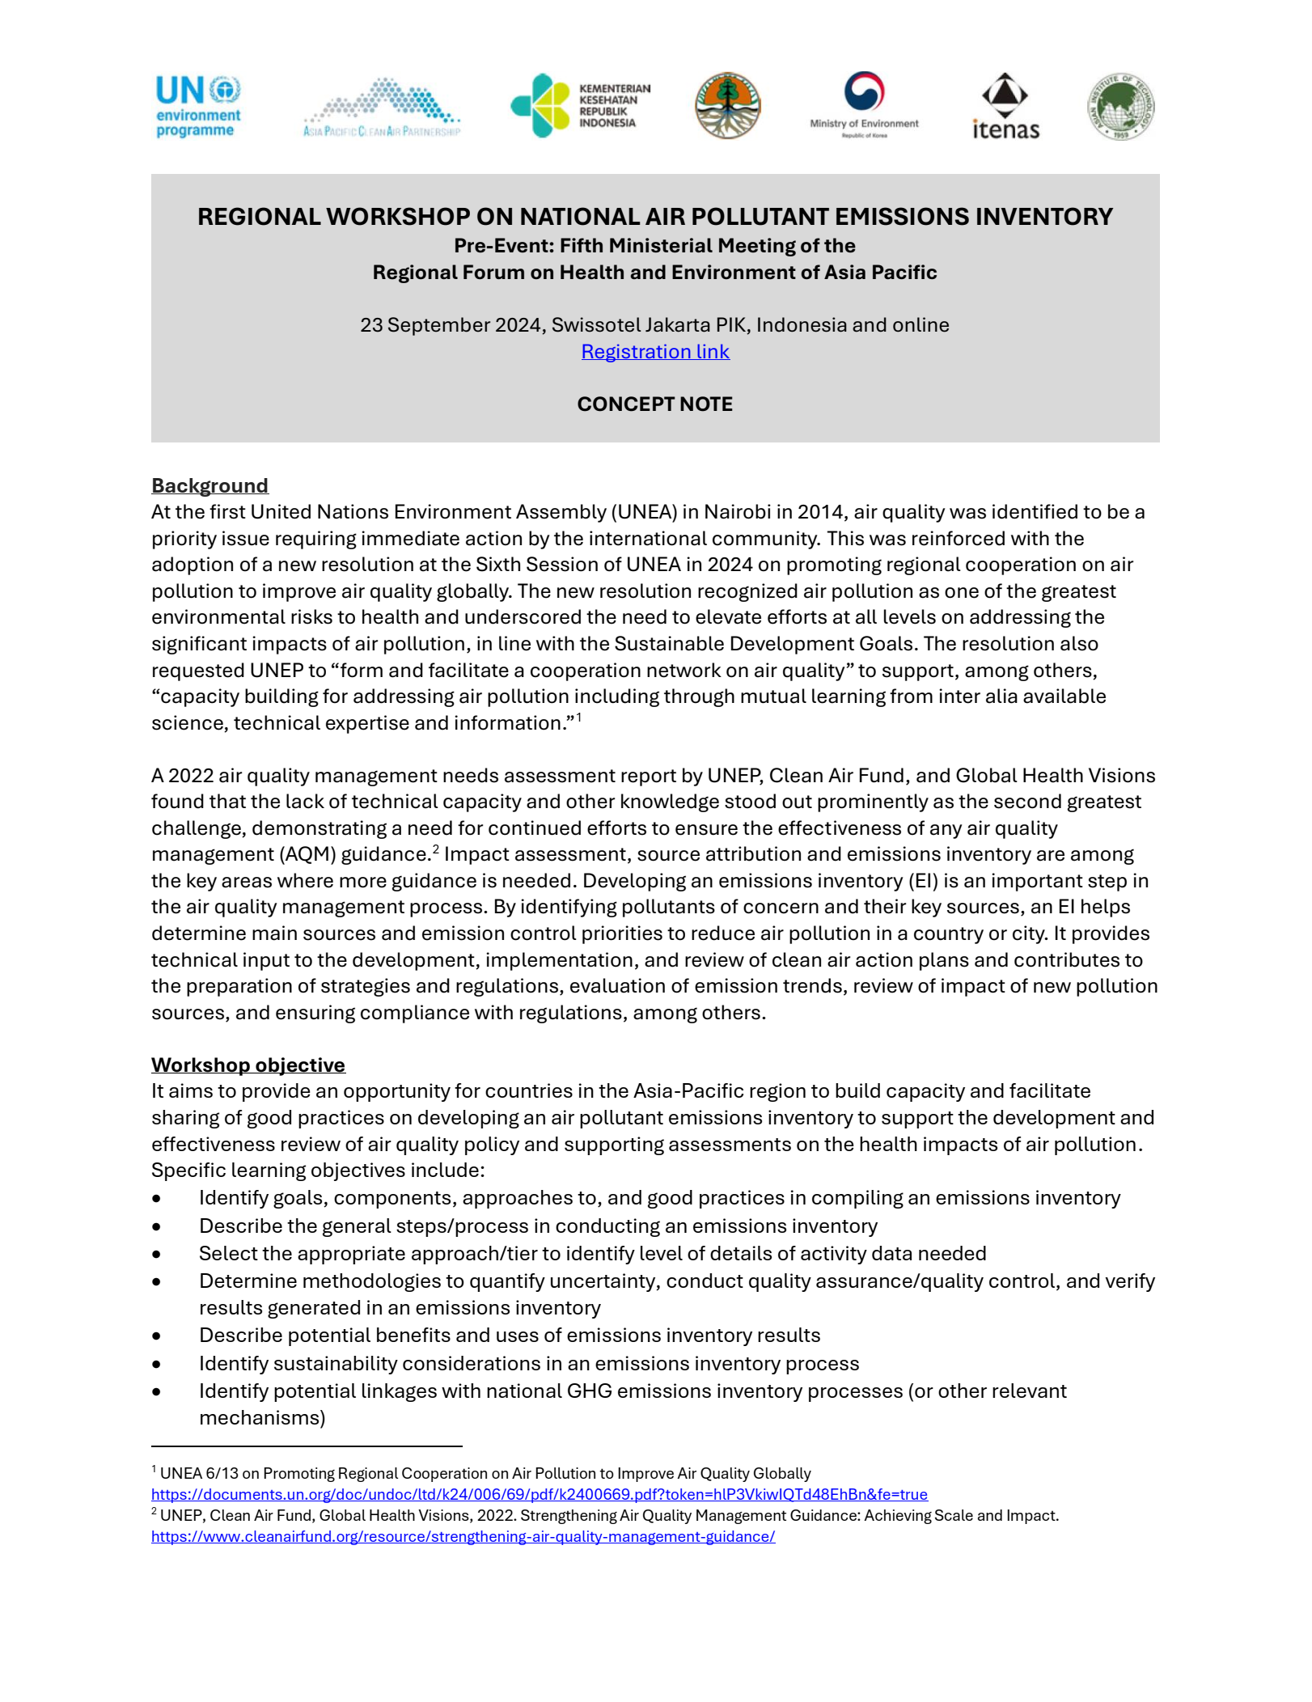

Date | On 5-8th September 2024
Title | Workshop Participation in Advanced Institute on Health Investigation and Air Sensing for Asian Pollution (AI on Hi-ASAP) workshop
paragraph | On 5-8th September 2024, Dr. Lai Nguyen Huy and Dr. Truong Thi Huyen (AirQC members) attended the Advanced Institute on Health Investigation and Air Sensing for Asian Pollution (AI on Hi-ASAP) training workshop in Putrajaya, Malaysia. This event is hosted and organized by the IRDR International Centre of Excellence (IRDR ICoE-Taipei) in partnership with the International Science Council (ISC), Future Earth Taipei, International Global Atmospheric Chemistry - Monsoon Asia and Oceania Networking Group (IGAC- MANGO), University of Putra Malaysia, and National University of Malaysia.  This workshop aims to provide young to mid-career practitioners and researchers interested in air pollution and health research in Asia with knowledge, experience, and hands-on practice in the techniques and methodologies required to conduct research with the aim of reducing the health risks of air pollution.  The details of the event can be found at https://www.ukm.my/talib/news/advanced-institute-on-health-investigation-and-air-sensing-for-asian-pollution-ai-on-hi-asap/
Photo | 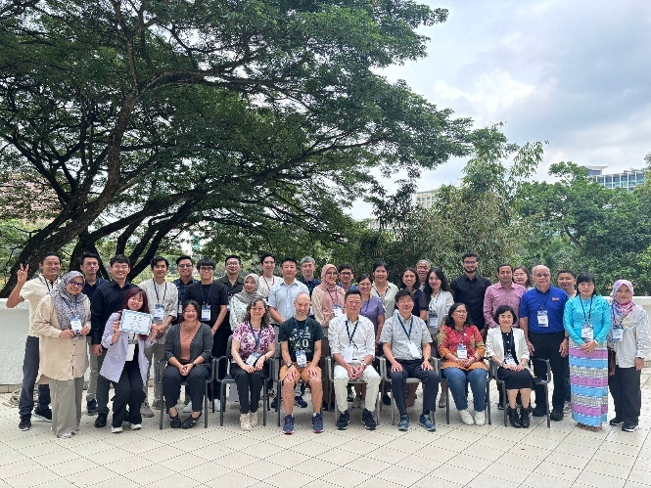  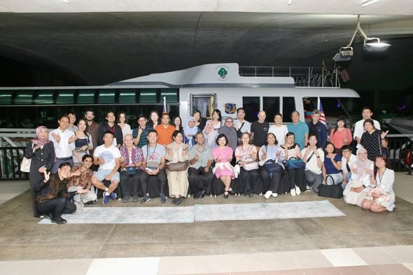

Media

Date | 23 September 2025
Title | Public Seminar at Universitas Sriwijaya, in Palembang, Indonesia, 23rd September 2025  Organization of Conferences/Seminars/Workshops
paragraph | On 23 September 2025, Prof. Nguyen Thi Kim Oanh and Dr. Lai Nguyen Huy (AirQC’s team) participated in a policy workshop in Jakarta, Indonesia, organized under the HEAL-HAZE and CANBREATHE projects.  During the workshop, presented the prototype of a DIY air purifier designed for Clean Air Room interventions and organized a panel discussion on “Community Empowerment for Environmental Health and Health Equity,” sharing experiences and lessons learned alongside Bicara Udara, Clean Air Asia, and Nafas.  The workshop aimed to promote multi-country collaboration and strengthen regional actions to improve community health resilience against air pollution. It served as a platform for dialogue among partners from Australia, Thailand, Cambodia, Laos, and Indonesia, encouraging knowledge exchange and capacity building for practical clean-air solutions.  Following the workshop, the AirQC team joined international partners in field visits to SD Muhammadiyah 1 School, Bappeda Litbang, and the Silaberanti Community in Palembang to identify suitable sites for implementing the Clean Air Room interventions.  The international project team also conducted a public seminar at Universitas Sriwijaya, engaging local stakeholders and academic partners to enhance collaboration and ensure the successful implementation of the HEAL-HAZE and CANBREATHE initiatives.
Photo | 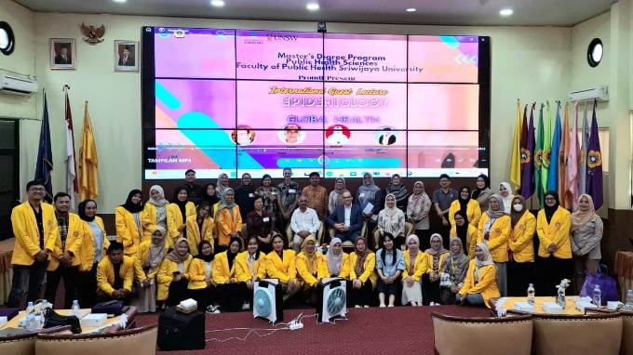
Date | 24 September 2025
Title | Regional Policy Workshop “Tackling the Health Impacts of Haze Pollution in Southeast Asia and Australia”, 24th September 2025
paragraph | On 24 September 2025, the Air Quality Nexus Center (AirQC) team participated in the Regional Policy Workshop on Tackling the Health Impacts of Haze Pollution in Southeast Asia and Australia, co-organized by the HEAL-HAZE and CANBREATHE projects. The workshop, held in Jakarta and co-hosted by the HEAL National Research Network at the University of Canberra, brought together experts, policymakers, and regional partners from across Southeast Asia and Australia, including representatives from the University of Indonesia, Clean Air Asia, Bicara Udara, NAFAS, Kopernik, and other key organizations.  The event aimed to strengthen regional collaboration on addressing the transboundary haze problem and its impacts on climate and public health. It provided a platform for dialogue and knowledge exchange on inclusive approaches to empower vulnerable communities, promote local adaptation strategies, and integrate cross-sectoral policies for emissions reduction and health equity. Key themes of the workshop included community resilience, health impacts of haze pollution, and opportunities for regional cooperation to support evidence-based policymaking for cleaner air in Southeast Asia.  Prof. Nguyen Thi Kim Oanh, Director of AirQC, served as a panelist in the session on “Regional Cooperation on Tackling Health Effects of Forest Fires.” She emphasized the importance of strengthening regional collaboration to reduce biomass open burning and address the associated transboundary haze phenomena. Prof. Kim also underscored the need for coordinated scientific research, shared data, and capacity-building initiatives to support sustainable policy actions across the region.  Details of the event can be found at Healthy Environments and Lives National Research Network – LinkedIn
Photo | 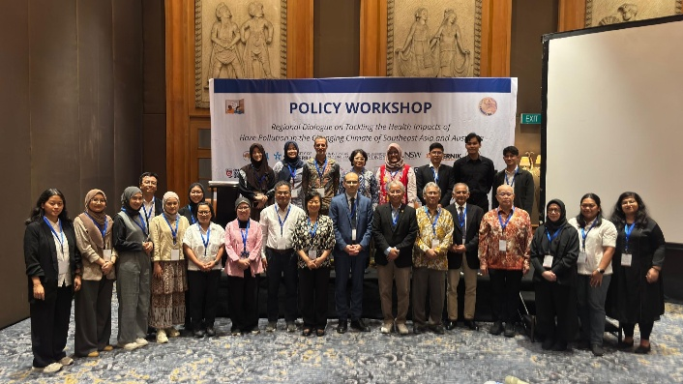  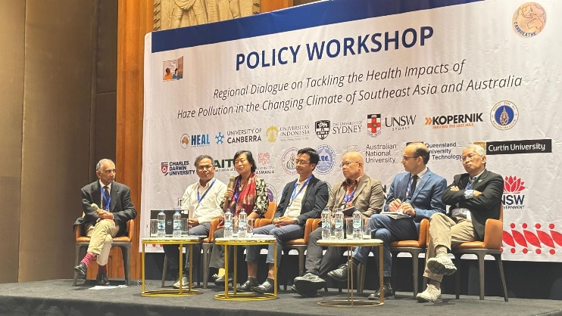

Date | 25 Sept 2025
Title | Participation in the Public Seminar “ENVIFAIR 2025 X RCCC UI” at the University of Indonesia, 25th September 2025
paragraph | The AirQC team participated in the Public Seminar “ENVIFAIR 2025 X RCCC UI”, which was organized by the Research Center for Climate Change (RCCC) and Faculty of Public Health, Universitas Indonesia, Depok, as a part of the HEAL-HAZE (link) and CANBREATHE (link) projects.  Prof. Kim Oanh and Dr. Huy also provided insights in the interviews conducted by the unverisity student union, highlighting the needs for science-based information for policy making and the AirQC activities within these two projects.
Photo  I have the photo when I answering the interview. | 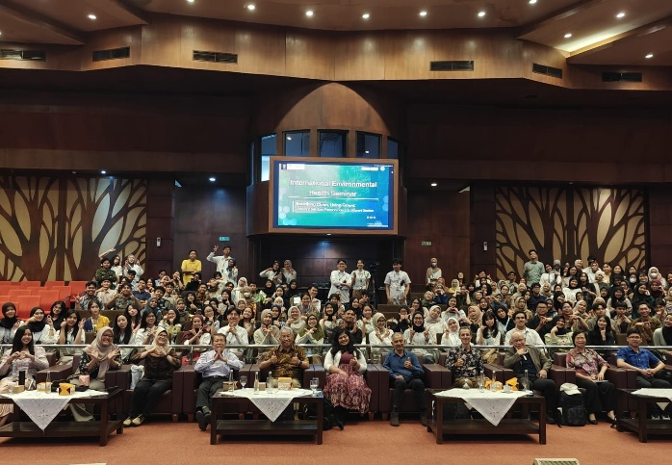

Date | 29 April, 2025
Title | Institutional Collaboration and Partnership Development: MoU with RCEC-AS (Taiwan):
paragraph | On 29 April, AirQC endorsed a Memorandum of Understanding (MoU) between AirQC and the Research Center for Environmental Changes, Academia Sinica (RCEC-AS), Taiwan. The agreement aims to advance collaborative research on air pollution, exposure profiling, and health impacts in Asia, thereby strengthening long-term regional cooperation.
Photo

Date | 22 April, 2025
Title | Interviewed by the Vietnamese National TV Channel, 22 Apr 2025
paragraph | Prof. Kim Oanh, Director of AirQC, was interviewed by the Vietnamese National TV channel (VTV1).  She discussed the importance of obtaining accurate emission data from different source sectors.  The full interview video can be found at https://www.youtube.com/watch?v=Sl-bWb8xQIU
Photo | 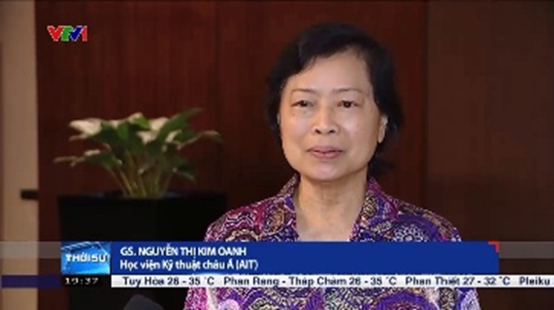

Date | 1 November, 2024
Title | Sustainable Development and Environmental Health” of the Beijing Forum 2024 (https://www.bjf.pku.edu.cn/forum/index.php ), 1st – 2nd, 2024
paragraph | Taking place from 1 to 3 November 2024 at Peking University, the Beijing Forum 2024 aimed to foster global dialogue guided by the principle of “The Harmony of Civilizations and Prosperity of All,” seeking advancement through innovation and mutual understanding among nations. Since its inception in 2004, the Beijing Forum has hosted over 7,000 distinguished guests from more than 80 countries and regions. The annual event, drawing on Beijing’s rich cultural heritage, is dedicated to advancing research on global issues and promoting academic development and social progress worldwide. The 21st Beijing Forum, with its comprehensive scope, addressed contemporary challenges through 13 thematic panels, two symposia, and three Beijing Forum Global events, promoting international cooperation and shared progress through open dialogue and mutual learning.  Prof. Nguyen Thi Kim Oanh, Director of AirQC, participated as a panelist in Session 3 “Air, Climate and Health” under the theme “Sustainable Development and Environmental Health” at the Beijing Forum 2024, held in Beijing, China. The forum emphasized the interlinkages between environmental systems, human health, and sustainable development, advocating for integrative and multidisciplinary approaches to address major global challenges such as air pollution, climate change, and health inequities.  Prof. Kim Oanh delivered an oral presentation on “Perspectives of Improving Air Quality with Multiple Benefits in Southeast Asia,” sharing valuable insights on air quality management and highlighting the interconnected impacts of air pollution, climate change, and public health. She also emphasized the importance of collaborative research and regional cooperation to strengthen evidence-based policymaking and advance sustainable air quality improvement across Southeast Asia. Details of the Beijing Forum 2024 can be found at Beijing Forum 2024.
Photo | // Ktoo: please check website, flyer, photo?? I will give one photo if I find it.  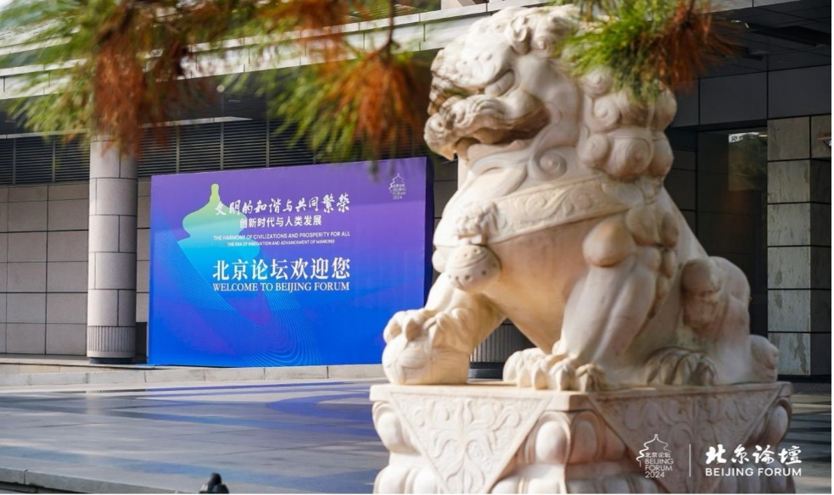

Date | 22 October 2024
Title | Regional Workshop “Identifying Air Pollution Sources Through Emission Inventory Event”, 22nd October 2024
paragraph | On 22 October 2024, Prof. Nguyen Thi Kim Oanh, Director of AirQC, participated as a guest speaker at the regional workshop “Identifying Air Pollution Sources Through Emission Inventory” organized by the World Resources Institute (WRI) and Environmental Defense Fund (EDF) in Jakarta, Indonesia. She delivered a presentation on “Development of Emission Inventory for Integrated Air Quality Management: SEA Regional Perspectives”, sharing her valuable insights into building high-quality source inventories in Southeast Asia.  The workshop provided a key opportunity to connect with regional experts, exchange knowledge on emission inventory methodologies, strengthen local capacities through public dissemination, and advance collective efforts to develop effective clean-air and climate-health solutions.
Photo | 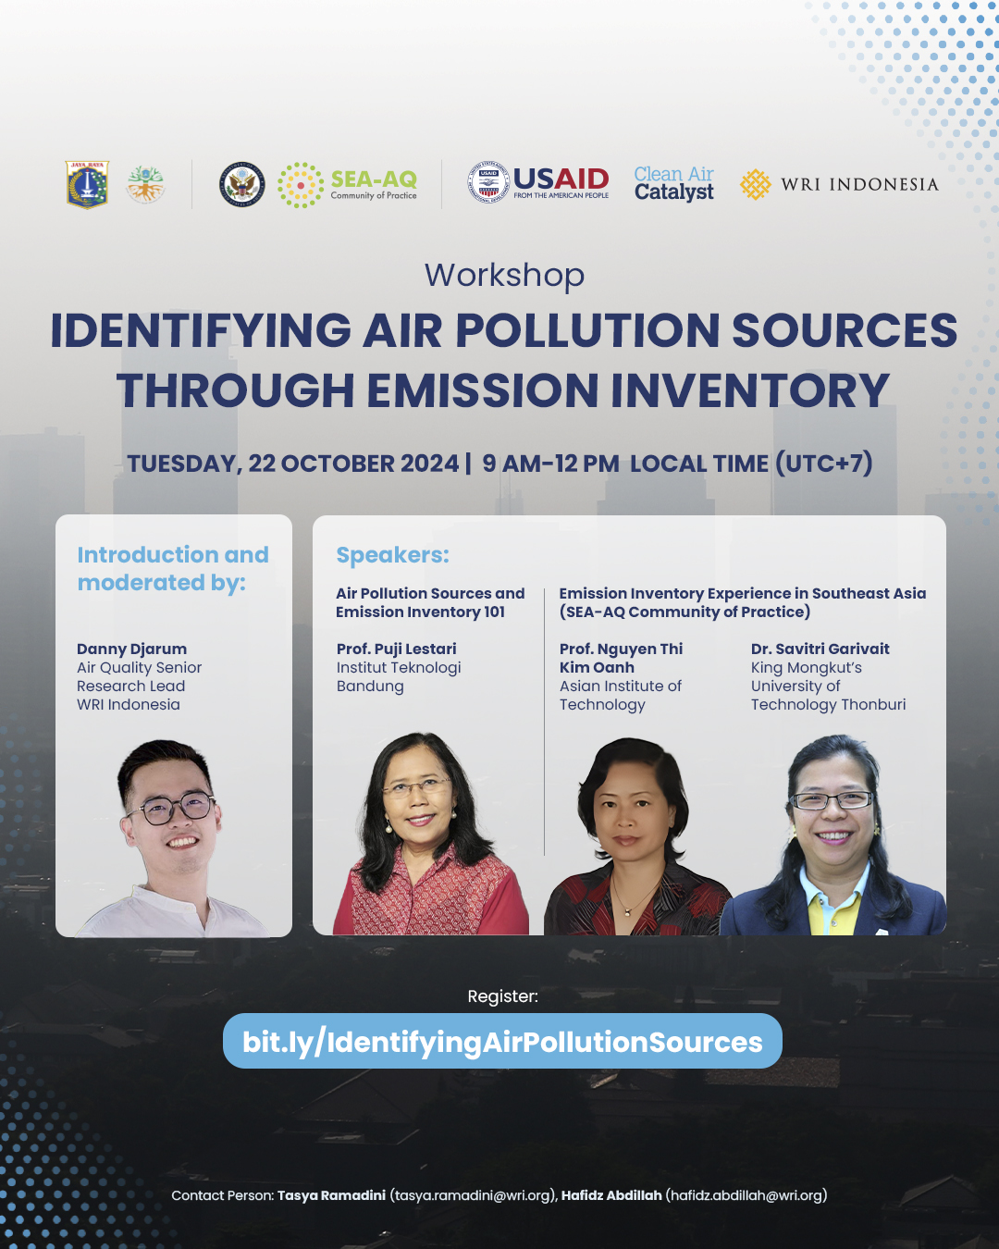

Date | On 17-18 October 2024
Title | Panelist at a side event of “Eighth Session of the Committee on Environment and Development (CED-8)”
paragraph | The AirQC team participated in the “Eighth Session of the Committee on Environment and Development (CED-8)” to be held at the United Nations Conference Centre (UNCC) in Bangkok, Thailand organized by the Ministry of the Environment of Japan (MOEJ) in collaboration with UNESCAP and several international institutions, including ROK, MOE, and ADPC.  The event provided a comprehensive overview of the current status and trends in air pollutant emissions and air quality across Asia and the Pacific, facilitating informed collective action among diverse stakeholders in support of the Regional Action Plan for Air Pollution (RAPAP). Key outcomes included heightened awareness of air quality trends relating to aerosols and trace gases, a better understanding of transboundary air pollution impacts and sources, and the identification of strategies to enhance regional efforts in tackling air pollution.  Prof. Kim Oanh served as a panelist at the side event “Review of Air Quality Status and Actions in Asia and the  Pacific; Air pollution in the region and opportunities to  strengthen regional action ”. She emphasized the importance of getting science- and evidence-based information to foster regional cooperation in dealing with the air pollution challenge, along with the need for capacity building.  The details of the event can be found at //  On 17th October 2024, Prof. Nguyen Thi Kim Oanh, Director of AirQC participated in the Eighth Session of the Committee on Environment and Development (CED-8) held at the United Nations Conference Centre (UNCC) in Bangkok, Thailand. The session and its side event were organized by the United Nations Economic and Social Commission for Asia and the Pacific (ESCAP), the Government of Japan, the Government of the Republic of Korea, the United Nations Environment Programme (UNEP), and the Asian Disaster Preparedness Center (ADPC).  The side event, “Review of Air Quality Status and Actions in Asia and the Pacific: Air Pollution in the Region and Opportunities to Strengthen Regional Action,” provided a region-wide overview of the current status and trends in air pollutant emissions and air quality across Asia and the Pacific. It aimed to strengthen collective action among diverse stakeholders in support of the Regional Action Programme on Air Pollution (RAPAP).  Key outcomes of the event included:  ✔ Strengthened awareness of air quality status and trends covering both aerosols (PM) and trace gases.  ✔ Improved understanding of transboundary air pollution sources and impacts across airsheds.  ✔ Identification of practical options to enhance regional cooperation and strengthen actions to tackle air pollution.  Prof. Nguyen Thi Kim Oanh, Director of AirQC, served as a panelist at the side event “Review of Air Quality Status and Actions in Asia and the Pacific: Air Pollution in the Region and Opportunities to Strengthen Regional Action.” She emphasized the importance of generating science- and evidence-based information to foster regional cooperation in addressing air pollution challenges, as well as the need for capacity building and sustained collaborative initiatives to enhance the effectiveness of air quality management in the Asia-Pacific region.  Details of the event are available at UNESCAP – Review of Air Quality Status and Actions in Asia and the Pacific (CED-8).
Photo | 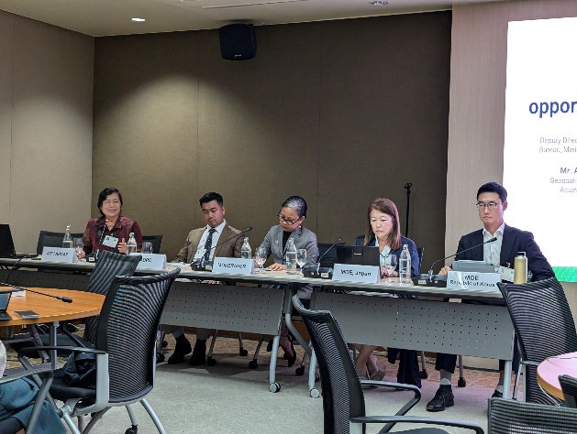  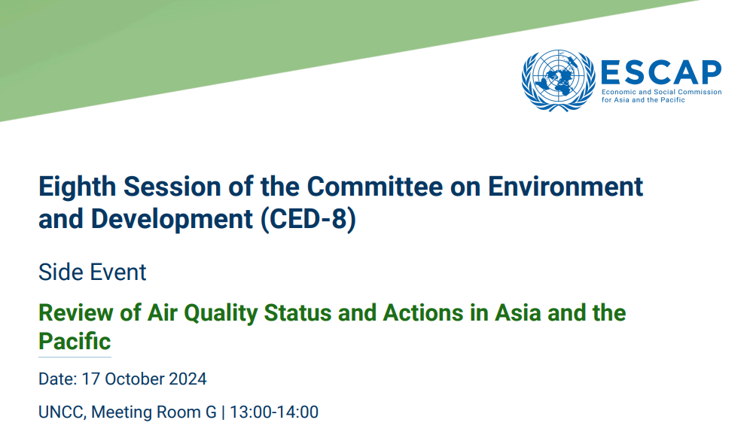

Date | 8 September 2025
Title | 5th International Forum on Transboundary Air Pollution in Commemoration of the International Day of Clean Air for Blue Skies, 8th September 2025
paragraph | On 8 September 2025, Prof. Nguyen Thi Kim Oanh, Director of the Air Quality Nexus Center (AirQC), participated in the 5th International Forum on Transboundary Air Pollution in Commemoration of the International Day of Clean Air for Blue Skies. The event was organized by the Ministry of Foreign Affairs (MOFA) of the Republic of Korea, with participation from policymakers, researchers, and representatives of international organizations working on regional air quality and environmental management.  The forum aimed to strengthen regional cooperation on air pollution mitigation and promote the implementation of integrated policies addressing the environmental and health impacts of transboundary pollution. It provided a platform for dialogue among key stakeholders to exchange knowledge, discuss technical and policy challenges, and identify collaborative strategies to achieve cleaner air in the Asia-Pacific region.  Prof. Kim Oanh delivered an online presentation titled “Wildfire Emissions in Southeast Asia: Multiple Effects on Regional Air Quality, Ecosystem, and Health.” Her talk highlighted the need for an airshed management approach to effectively address transboundary air pollution challenges. She also shared insights from the Center’s ongoing research under the HEAL-HAZE and CANBREATHE projects, emphasizing their contributions to improving regional understanding of wildfire impacts and promoting evidence-based solutions for cleaner air.  Details of the event can be found at Ministry of Foreign Affairs, Republic of Korea.
Photo | 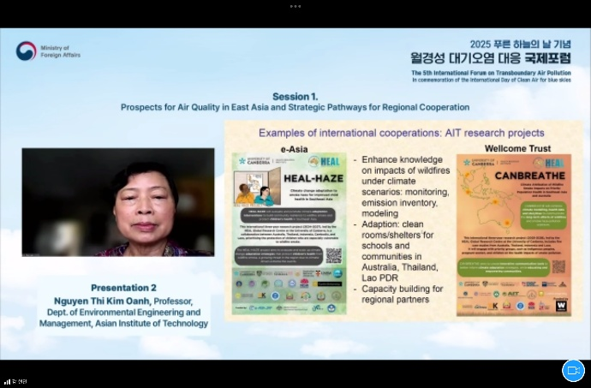

Date | 19-22 May 2025
Title | Air Sensors International Conference (ASIC), Bangkok, Thailand, 19th – 22nd May 2025
paragraph | From 19–22 May 2025, Prof. Nguyen Thi Kim Oanh, Director of AirQC, participated in the Air Sensors International Conference (ASIC) held in Bangkok, Thailand. The conference was organized by the Air Quality Research Center, University of California, Davis, USA, and brought together global experts, researchers, and practitioners working on sensor technology and data-driven air quality management.  Prof. Kim Oanh served as a member of the Technical Planning Committee of ASIC, contributing to the scientific coordination of conference sessions. She delivered an oral presentation on “Evaluation of Low-Cost Sensors in the Monitoring of Surface Ozone under Different Environmental Conditions” and co-chaired the session on “Sensor Performance Evaluation.” In addition, she also chaired the session on “Validating Air Sensors and Expanding Data Networks.”  The conference provided a valuable platform for sharing advancements in air sensor technologies, exploring opportunities for international collaboration, and promoting the integration of sensor-based monitoring systems for improved air quality management. More details about ASIC 2025 can be found at Air Quality Research Center – UC Davis
Photo | 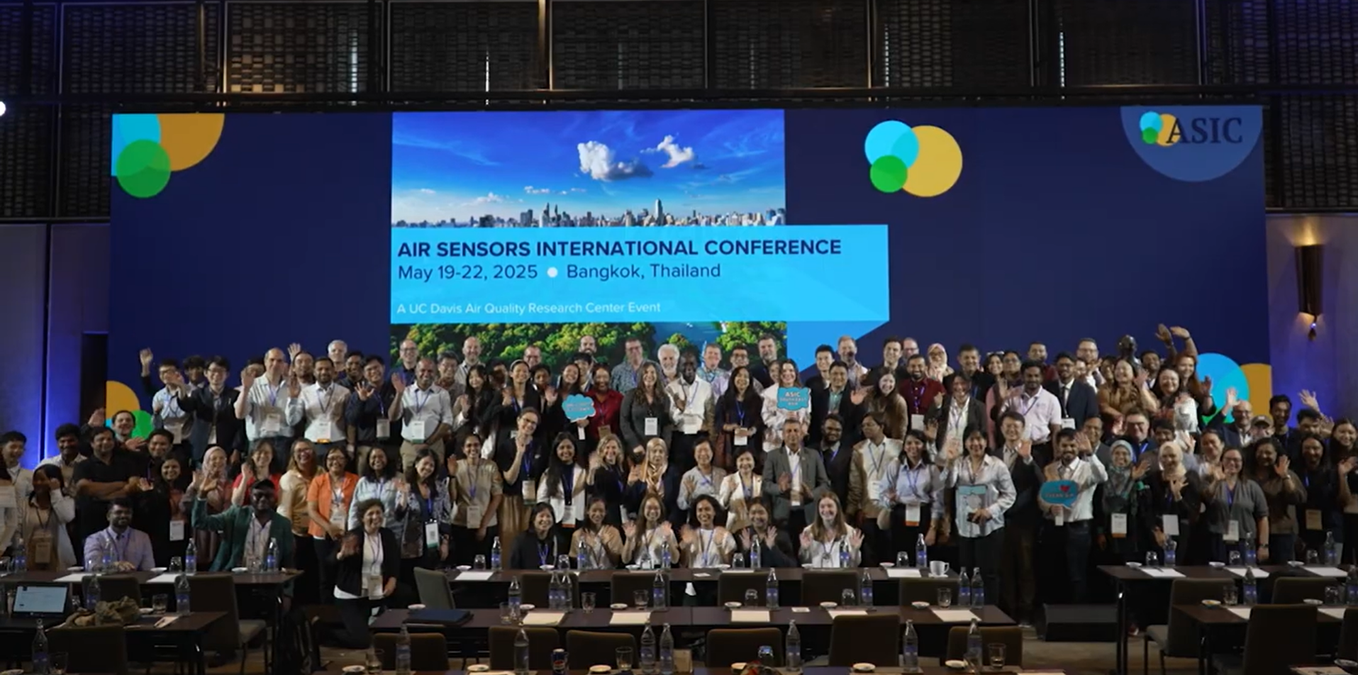
 | 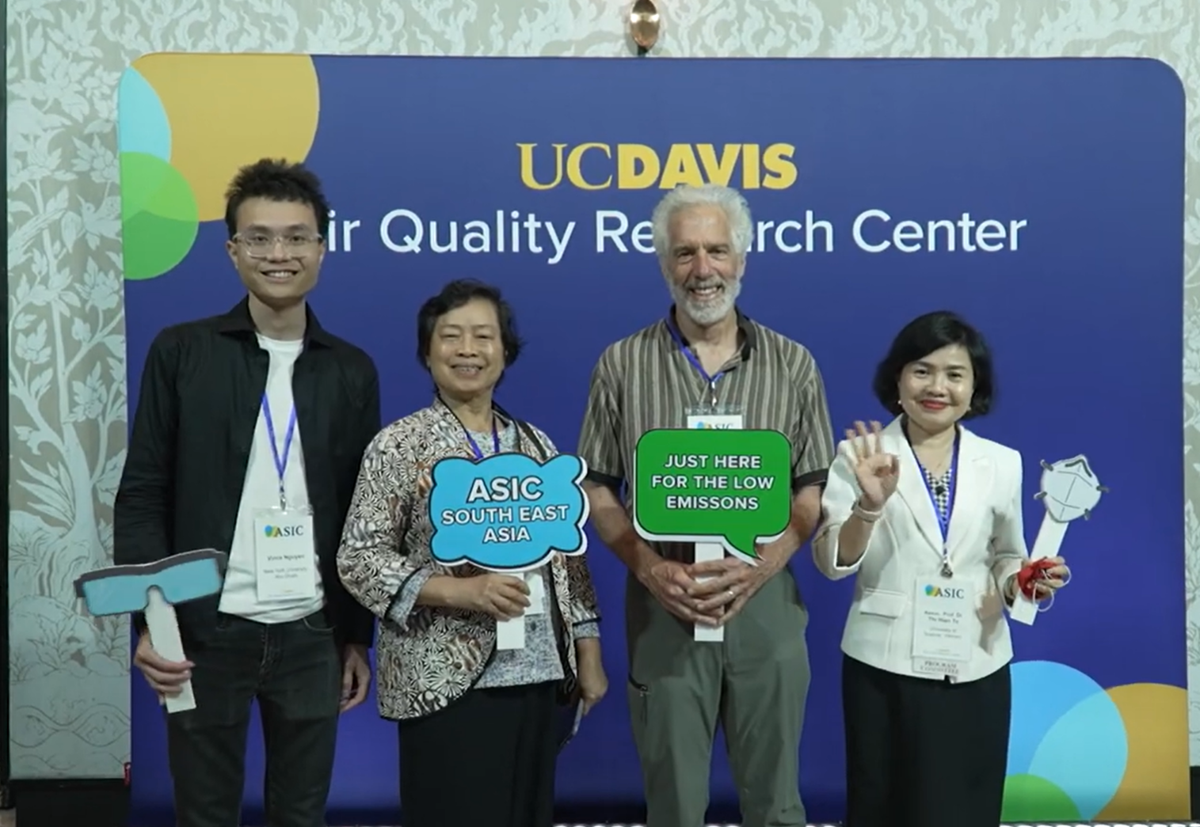

Date | 24-25 April, 2025
Title | National Scientific conference on “Combating Air Pollution and Improving Air Quality in Viet Nam”, Hanoi, Vietnam, 24th-25th Apr 2025.
paragraph | On 24–25 April 2025, Prof. Nguyen Thi Kim Oanh, Director of the Air Quality Nexus Center (AirQC), participated in the National Scientific Conference on “Combating Air Pollution and Improving Air Quality in Viet Nam” held in Hanoi. The event was co-organized by the Ministries of Agriculture, Environment, and Health, in collaboration with the United Nations Development Programme (UNDP), World Health Organization (WHO), and Clean Air Asia (CAA).  The conference aimed to foster dialogue among policymakers, scientists, and practitioners to identify effective measures to combat air pollution, improve air quality, and promote sustainable urban development in Viet Nam.  This conference is a vital forum not only for assessing the current situation and sharing international experiences but also for proposing innovative scientific solutions aligned with trends in digital transformation, artificial intelligence, and practical feasibility—all aimed at reducing pollution and achieving the goal of “Blue Skies – Clean Air”.  More than 200 delegates attended the conference, including leading experts from Tsinghua University, Peking University (China), and the Air Quality Nexus Center (AIT), alongside representatives from various ministries (Construction, Health, Industry and Trade), key localities such as Ha Noi, Hung Yen, Bac Ninh, Ho Chi Minh City, and major corporations, associations, enterprises, and international organizations.  Prof. Kim Oanh delivered a technical presentation on “Integrated Air Quality Management – with Focus on Technical Tools” and contributed as a panelist. She emphasized the importance of integrating science-based tools and regional cooperation to enhance policy implementation and achieve long-term improvements in air quality management across Viet Nam and the wider region.  Further information on the conference can be found at https://www.undp.org/vietnam/press-releases/national-scientific-conference-combating-air-pollution-and-improving-air-quality-viet-nam
Photo | 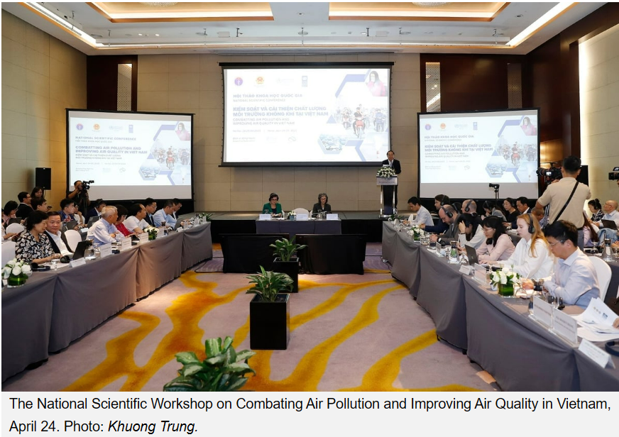  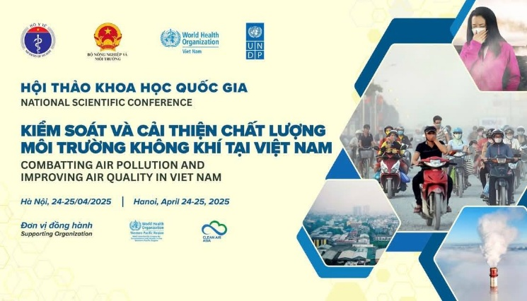  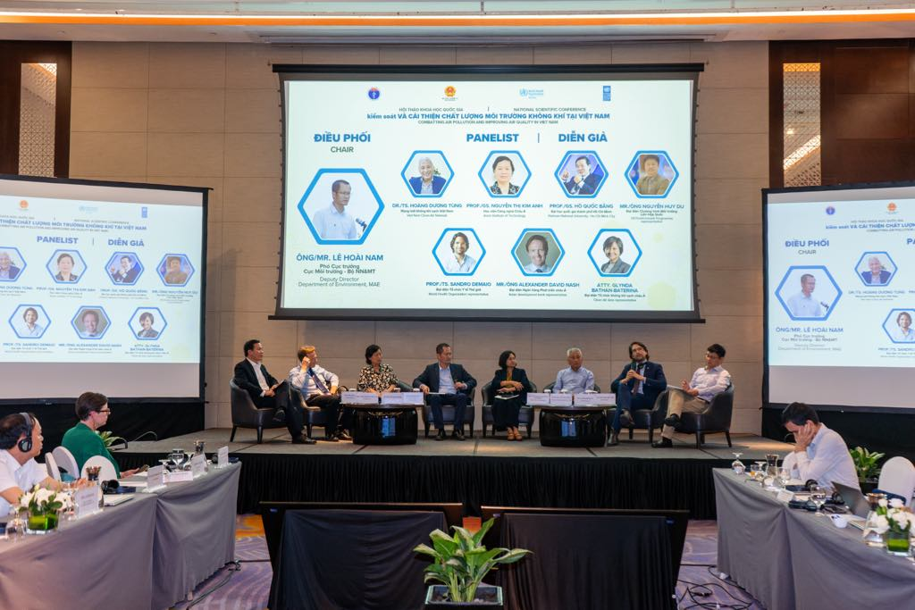

Date | 1 August 2025
Title | Mitigation Potential of GHG Emissions from Open Waste Burning
paragraph | On 1st August 2025, Prof. Kim Oanh, Director of AirQC, was invited as an online guest speaker at the regional workshop “Mitigation Potential of GHG Emissions from Open Waste Burning under Present and Future Scenarios: Cases of South Asian Countries – Nepal and Bangladesh” held in Kathmandu, Nepal.  The workshop was jointly organized by the Center of Research for Environment, Energy and Water (CREEW), Nepal; the University of Dhaka, Bangladesh; and Kobe City University of Foreign Studies, Japan, with support from the Asia-Pacific Network for Global Change Research (APN).  Prof. Kim Oanh delivered a presentation on “Reflections on Findings and Roadmap: Bridging Science and Policy”. Her presentation topic was on the emissions of dioxins from waste open burning activities.
Photo | 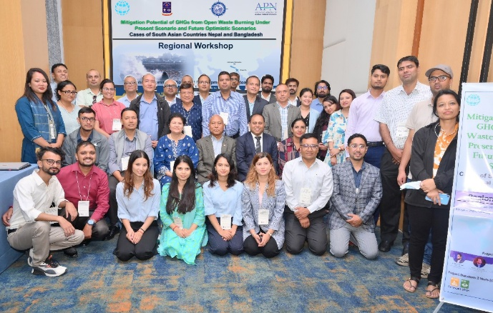

Date | 10 July, 2024
Title | Launch Ceremony of the AirQC
paragraph | On 10th July, 2024, the AirQC (AirQC) hosted its official launch ceremony, marking a significant milestone in advancing research, innovation, and collaboration to tackle the growing challenge of air pollution across Asia.  Led by Distinguished Professor Nguyen Thi Kim Oanh, the Center aims to strengthen capacity building and cutting-edge research in atmospheric sciences. AirQC fosters multidisciplinary collaboration within AIT and with international partners, focusing on integrated approaches to mitigate air pollution’s impacts on health, ecosystems, and climate. Its mission emphasizes developing cost-effective, science-based solutions and supporting governments in implementing effective clean air policies.  During the inauguration, Prof. Kazuo Yamamoto, President of AIT, reaffirmed AIT’s strong commitment to addressing air pollution and leading the way toward a healthier, cleaner, and more sustainable future. He encouraged all stakeholders to collaborate, exchange ideas, and work collectively toward the shared goal of improving air quality for all, expressing his enthusiasm for the impactful outcomes that will emerge from the Center.  Dr. Bindu Lohani, Chairman of Clean Air Asia and AIT Board Member, highlighted that improving air quality is fundamental to community health and well-being. He emphasized the importance of implementing innovative solutions, establishing robust policies, and fostering collaboration among governments, organizations, and communities to achieve cleaner air and a stable climate.  In her remarks, Prof. Nguyen Thi Kim Oanh, Director of the AirQC underscored the urgent global need for actionable solutions to combat air pollution. She called for a united approach centered on airshed management and transboundary cooperation, stressing that the Center is poised to spearhead these efforts by engaging with strategic partners across Asia and beyond to drive meaningful progress and multiple co-benefits for clean air, human health, ecosystems, and climate.  The event also featured a presentation by Assoc. Prof. Dr. Wenchao Xue, Chair of the Environmental Engineering and Management (EEM) program at AIT, who shared perspectives on integrated environmental research approaches in Asia.Following this, notable guests including Ms. Le Thanh Thuy, Head of Project Management and Communication of Hanoi EPA, Ministry of Natural Resources and Environment (MONRE), Vietnam; Prof. Sotiris Vardoulakis, Director, NHMRC Healthy Environments And Lives (HEAL) National Research Network, University of Canberra, Australia; Dr. Eric Zusman, Research Director, Center for Sustainability Governance, Institute for Global Environmental Strategies (IGES), Japan; Mr. Bhushan Tuladhar, Chief of Party, USAID Clean Air, FHI 360-Nepal; Mr. Bert Fabian, Coordinator, Secretariat for the EANET, UN Environment Programme, Asia and the Pacific, and Prof. Joyashree Roy Director of SMARTS center, AIT delivered their remarks. These sessions provided valuable insights and fostered discussions on the nexus of air quality, health, ecosystems, and climate.  The launch event concluded with a call to action for continued collaboration and innovation. It highlighted AIT’s leadership in driving impactful research and policy engagement to improve air quality, strengthen public health, and enhance climate resilience across the region.  The details of the event can be found at https://ait.ac.th/2024/07/air-quality-nexus-center-launched-at-ait-to-combat-air-pollution-in-asia-and-beyond/
Photo | 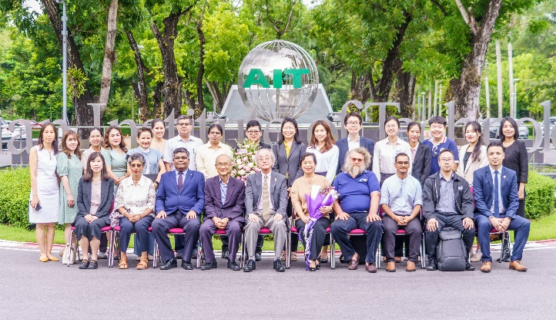

Date | 4 October 2024
Title | The annual symposium of the international research network “Impact of Black Carbon in Southeast Asia” (IRN SOOT-SEA)
Paragraph | The annual symposium of the international research network “Impact of Black Carbon in Southeast Asia” (IRN SOOT-SEA), co-organized by the AirQC (AIT) and French National Research Institute for Sustainable Development IRD, was held at AIT Conference Center on October 4, 2024. The events brought 25 participants from the French and ASEAN experts in air quality and climate research.  The day before the workshop, on 3rd October 2024, AirQC warmly welcomed IRD representatives to visit the Environmental Engineering and Management (EEM) Ambient Laboratory, Air Quality Modeling Laboratory, and EEM Main Laboratory.  The symposium opened with a speech by Prof. Pai-Chi Li, President of the AIT, underlining the importance of this meeting in assessing work on air pollution in the Greater Mekong Region. SOOT-SEA is an international network focused on understanding the impact of black carbon in Southeast Asia, funded by IRD, France. This project includes key partners from France (Institute of environmental geosciences (IGE)), Thailand (AirQC (AIT) and Environmental Science Research Center of Chiang Mai University (ESRC-CMU)), Vietnam (University of Engineering and Technology of the National University of Vietnam (VNU-UET), University of Science of the National University of Vietnam in Ho Chi Minh City (VNUHCM-US)) and Laos (Center of Excellence in Environment of the National University of Laos (NUoL-CoEE)).  The workshop provided an invaluable platform to promote and structure research and capacity-building efforts regarding black carbon and air pollution challenges within the region. It aimed to foster North-South and South-South collaborations and set the groundwork for future co-funding opportunities from national and international organizations.  The details of the event can be found at https://en.ird.fr/soot-sea-annual-symposium-international-collaboration-better-air-quality
Photo | 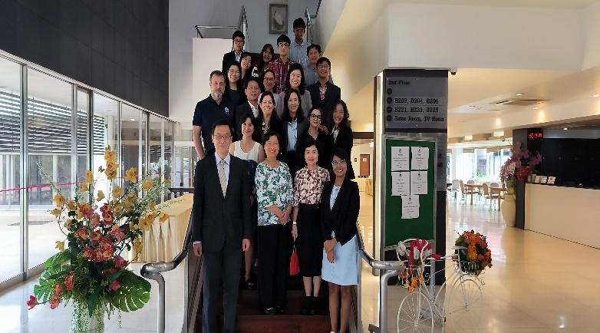
 | 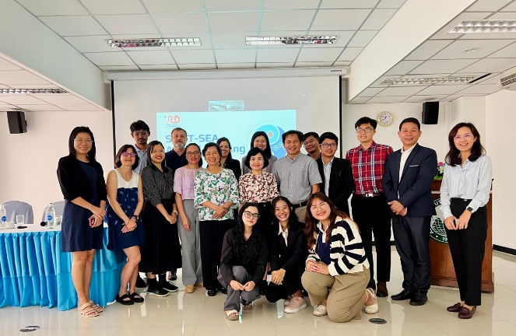
 | 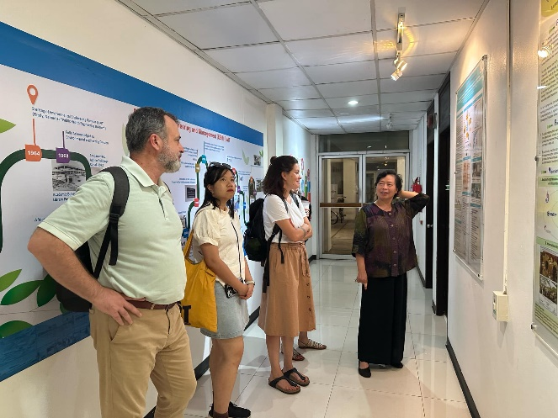
 | 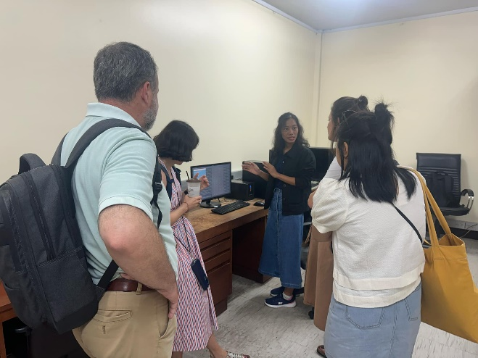

Date | 18 June, 2025
Title | Public Seminar on ‘Wildfire Smoke: Health Impacts and Adaptation in Southeast Asia and Australia”
paragraph | On 18th June 2025, the AirQC (AirQC) hosted the public seminar on “Wildfire Smoke: Health Impacts and Adaptation in Southeast Asia and Australia”. This hybrid event brought together // regional and international experts to discuss health risks from wildfire smoke and haze under climate change.  The event is within the framework of CANBREATHE and HEAL-HAZE projects. Before the public seminar happened, Dr. Lai Nguyen Huy presented an overview of the AirQC, highlighting its key research areas and projects.  The event focused on climate attribution, health assessments, and adaptation for vulnerable groups. Key presentations covered early warning systems, health effects, and interventions like clean air rooms. The seminar also promoted policy dialogue and science-based regional planning. Prof. Kim Oanh, Director of AirQC, was also the panelist of the event, sharing her valuable insight on the situation of wildfire in Southeast Asia and its effects.  On the same date, AirQC hosted the guests to a guided laboratory tour of AIT’s research facilities, including the Environmental Engineering and Management (EEM) Ambient Laboratory, Air Quality Modeling Laboratory, and the EEM Main Laboratory.  The details of the public seminar can be found t https://ait.ac.th/event/public-seminar-wildfire-smoke-health-impacts-and-adaptation-in-southeast-asia-and-australia/
Photo | 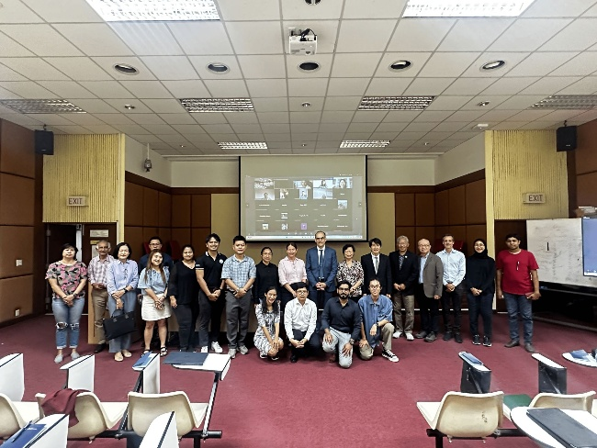
 | 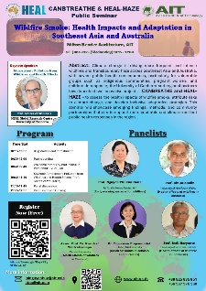
 | 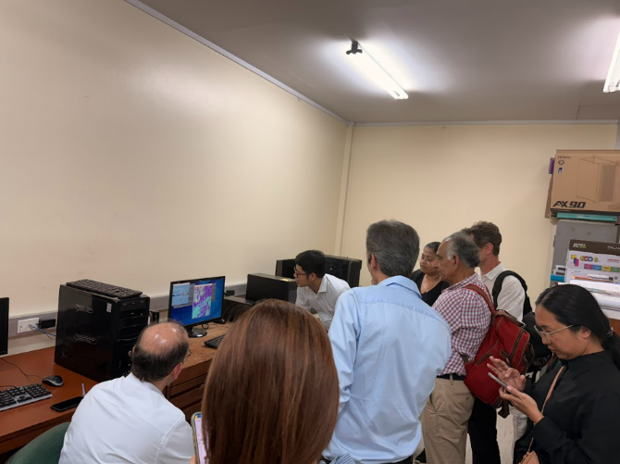
 | 